Power BI Sales Analysis – Assignment

List of Orders - Raw data showing order information
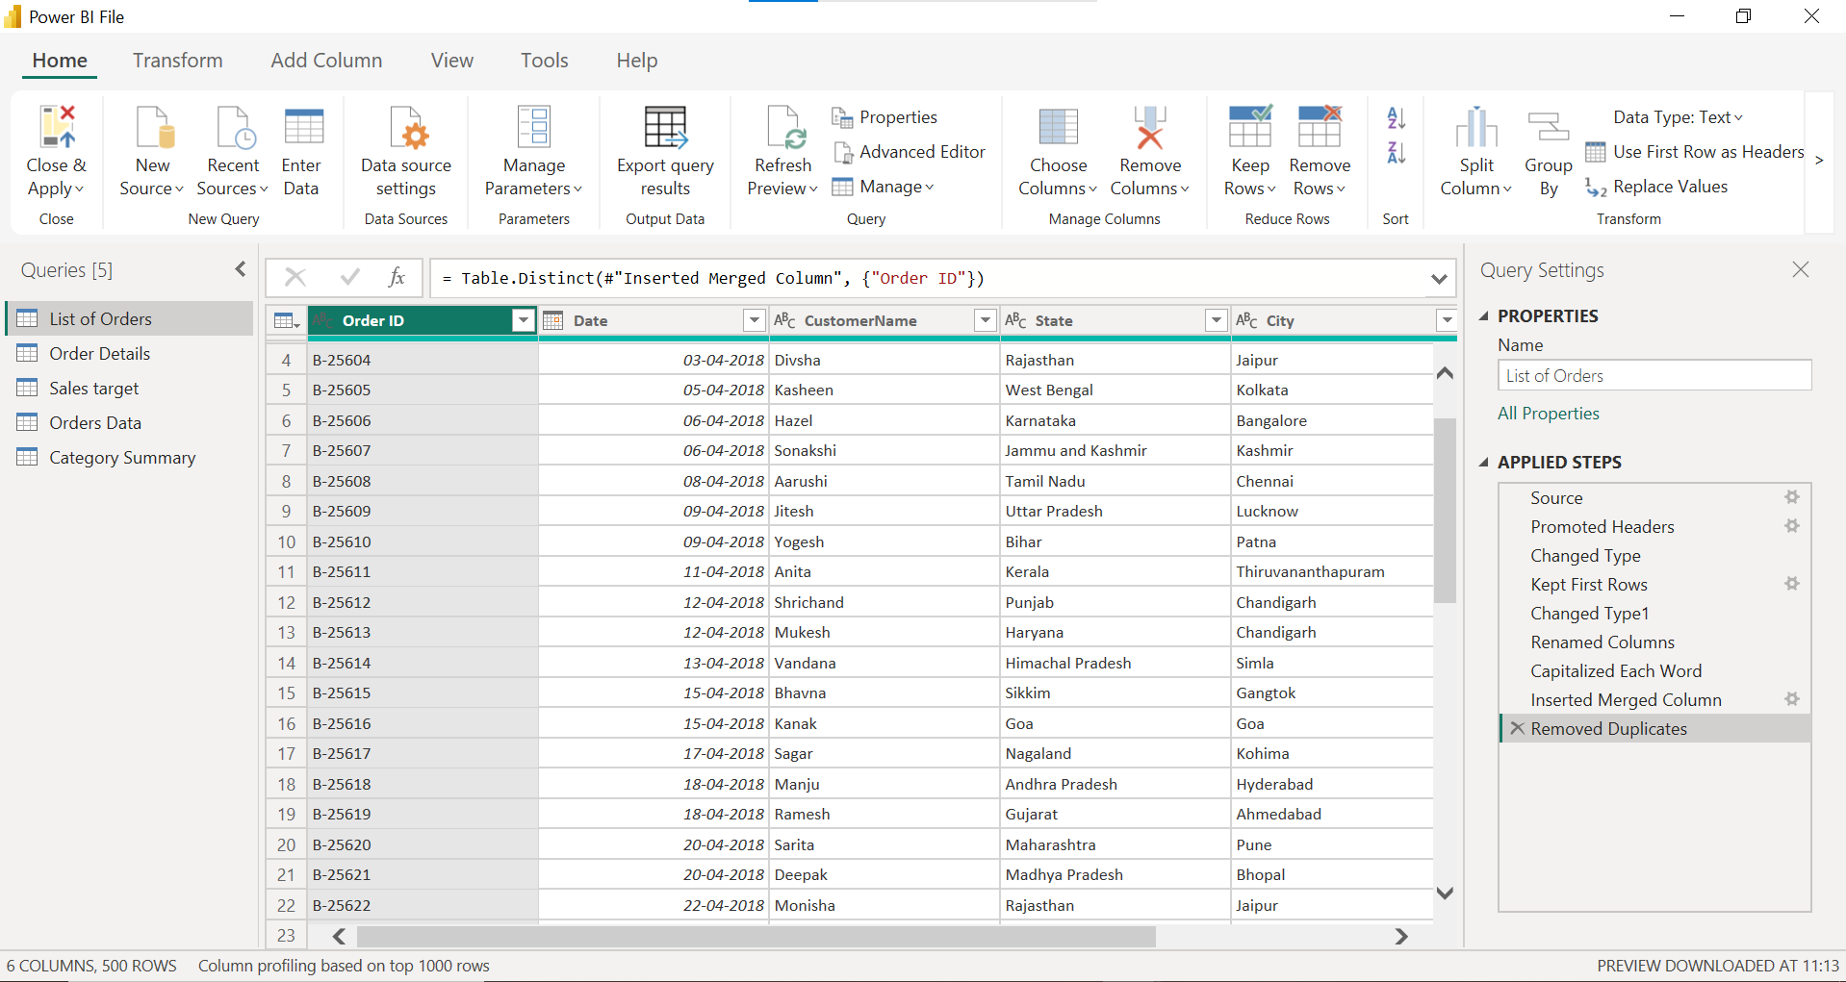

Order Details with Profit Margin - Added Profit Margin = Profit/Amount*100
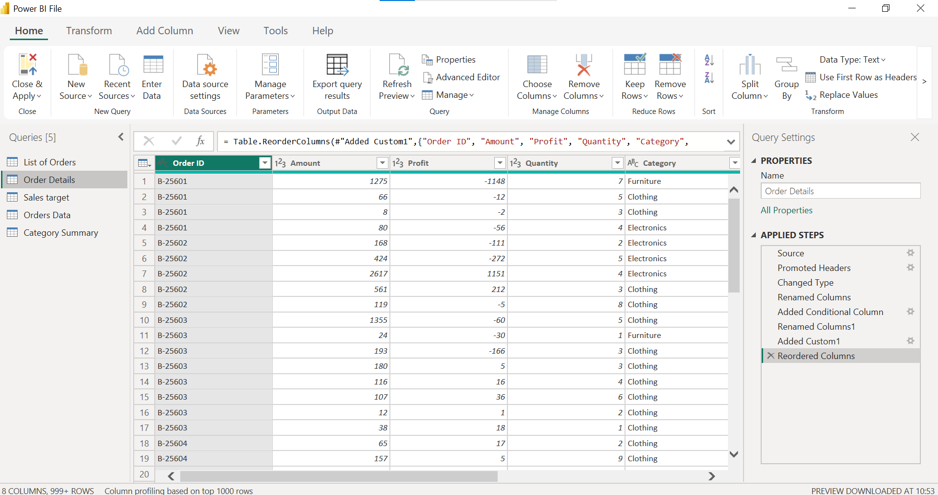

Data Types - Changed Amount to Fixed Decimal, Date to Date type
Orders Data (Merged Table) - Merged List of Orders with Order Details using Order ID
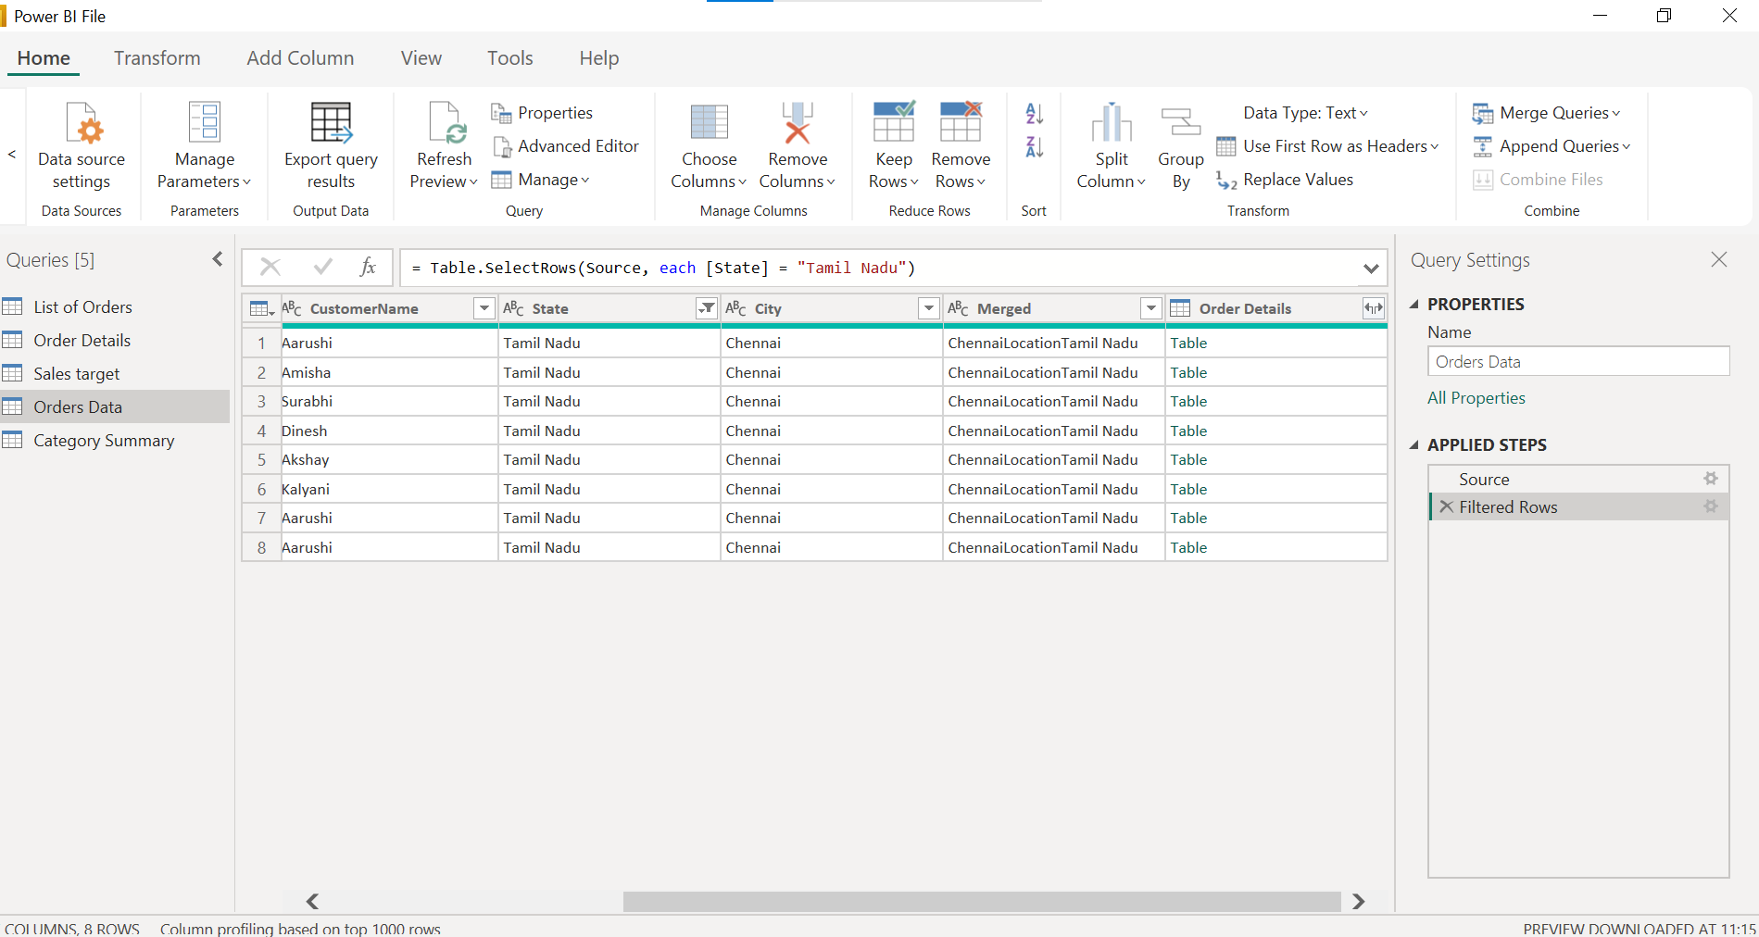
Orders Data Sorted by Date - Order Date sorted descending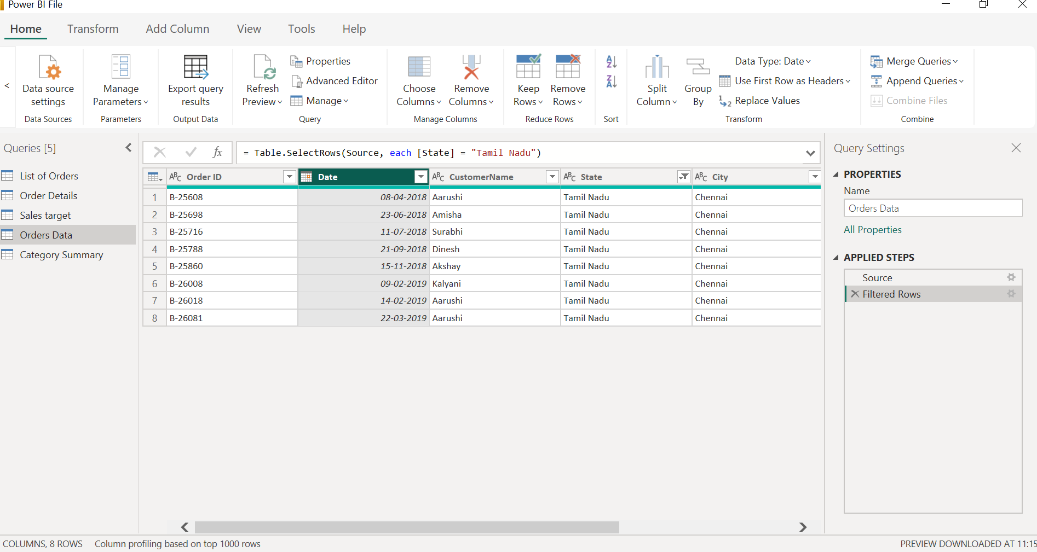
Orders Data Tamil Nadu Filter - Filtered State = Tamil Nadu only
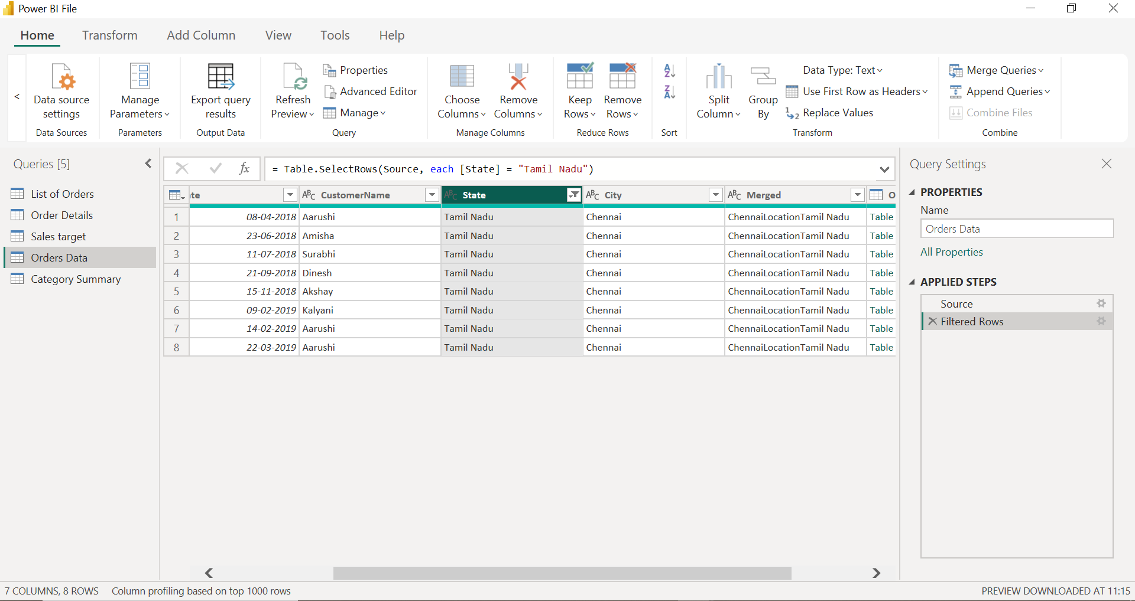
Category Summary (Group By result) - Grouped by Category with Count, Sum and Average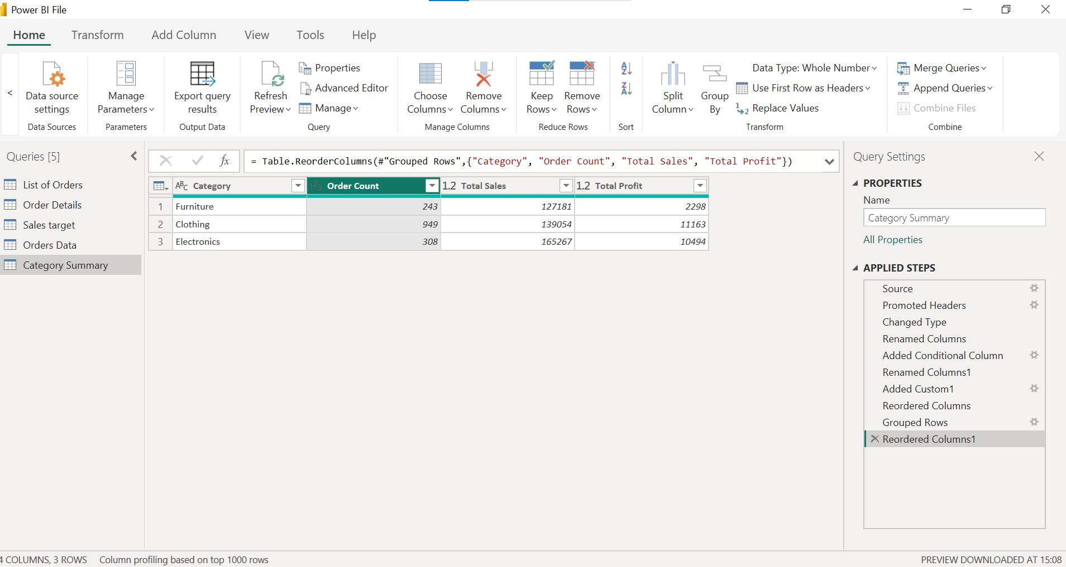
Sales Target table - Sales target data by category
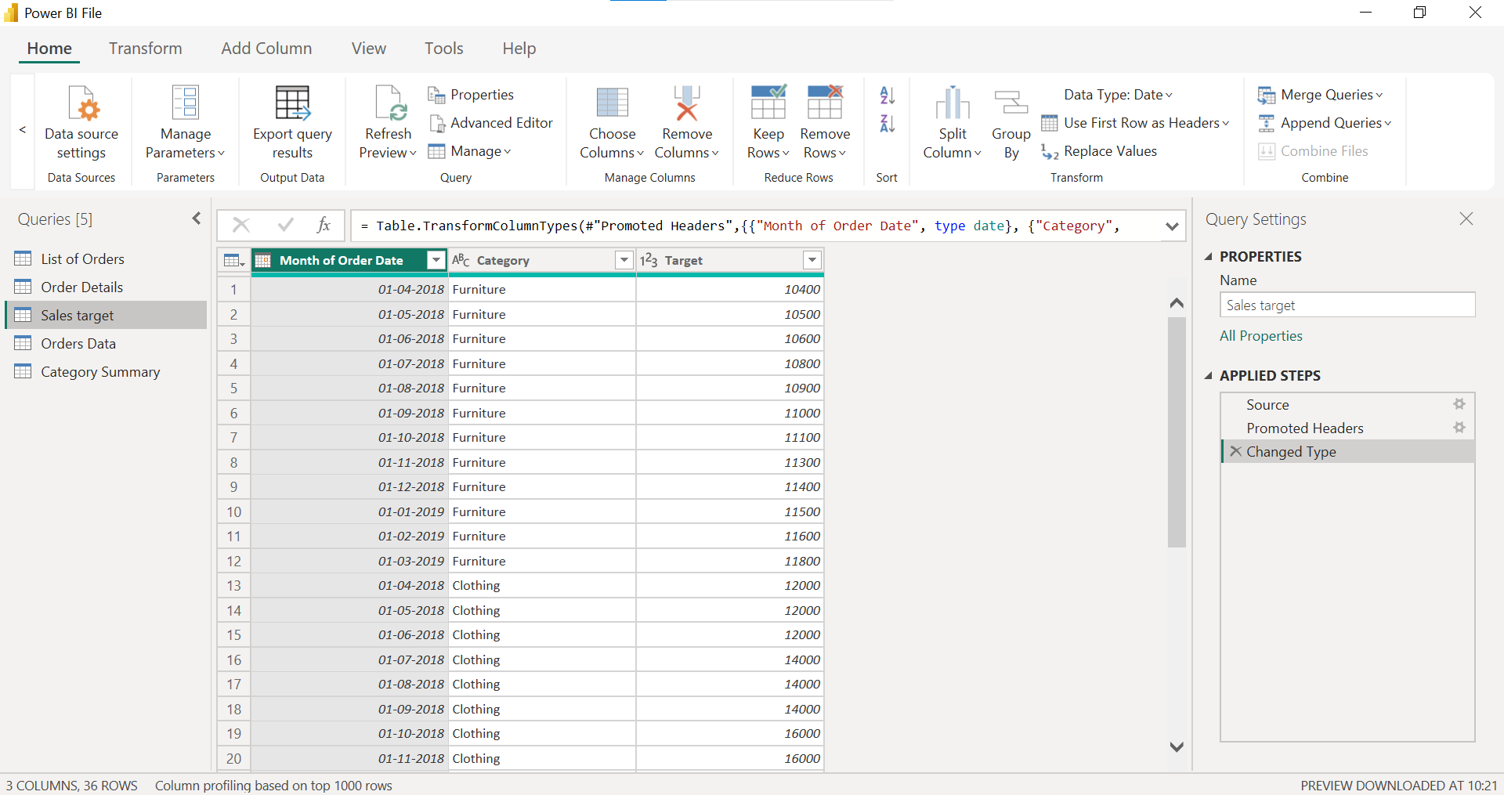

Model View Relationships- Relationships created between all tables using Order ID and Category


